Purpose: The students will learn how to use the filers in Photoshop to add aesthetics to their Photo, then save them to their home drive. The students will also show their mastery of Photoshop by applying filters to their Photos. The students will show their mastery of a digital camera by taking pictures of themselves to use for the assignment. Rules of Composition will be used to take Photo’s that are to be used for the assignment. Students will turn in 5-4” x 6” jpg files, 300 resolution, original digital prints.

Assignment: The student will shoot 5 pictures using two or more rules of composition in each picture. Save the Photos in their home drive. Students will copy and paste 4 of the same Photos to one 4”x6” canvas. Different filters will be applied to each of the four prints on the canvas. All pictures must have different filters! No two can be the same. The student will turn in 5 4” x 6” jpg files, 300 res, original prints.

VAPA Content Standards Met:
2.1 Solve a visual arts problem that involves the effective use of the elements of art and the principles of design.
2.2 Prepare a portfolio of original two-and three-dimensional works of art that reflects refined craftsmanship and technical skills.
2.3 Develop and refine skill in the manipulation of digital imagery (either still or video).
Grading: Rate your pictures from 1 to 6 in each of the following categories.
ALL items marked with ► must be graded 3 or higher to pass the assignment.
Any ► item marked 0, 1, or 2 must be fixed to a 3 to pass assignment.
► = ES&C | Lowest --------- Highest |  |  |  |  | EC
► File Name | 1 | 2 | 3 | 4 | 5 |  | All files renamed properly.
► File Type | 1 | 2 | 3 | 4 | 5 |  | All files converted to JPEG format.
► Size | 1 | 2 | 3 | 4 | 5 |  | All pictures proper size.[ 4”W x 6”H or 6”W x 4”H ]
► Resolution | 1 | 2 | 3 | 4 | 5 |  | Resolution is 300 dpi for all
► Uploaded | 1 | 2 | 3 | 4 | 5 |  | Folder/Files uploaded correctly to S:\ drive.
► Composition | 1 | 2 | 3 | 4 | 5 | 6 | 2 Rules of Composition used in each picture.
Contrast | 1 | 2 | 3 | 4 | 5 |  | Contrast looks good in the Photo.
Picture 1 | 1 | 2 | 3 | 4 | 5 | 6 | Picture is creative and different filters added.
Picture 2 | 1 | 2 | 3 | 4 | 5 | 6 | Picture is creative and different filters added.
Picture 3 | 1 | 2 | 3 | 4 | 5 | 6 | Picture is creative and different filters added.
Picture 4 | 1 | 2 | 3 | 4 | 5 | 6 | Picture is creative and different filters added.
Picture 5 | 1 | 2 | 3 | 4 | 5 | 6 | Picture is creative and different filters added.
Creative | 1 | 2 | 3 | 4 | 5 | 6 | Photos are interesting and Creative.
Photoshop | 1 | 2 | 3 | 4 | 5 | 6 | Shows skills in the use of Photoshop tools.
Questions | 1 | 2 | 3 | 4 | 5 | 6 | Questions on back answered.
Rubric | 1 | 2 | 3 | 4 | 5 |  | Self scored.
Meets Deadline | 1 | 2 | 3 | 4 | 5 | 6 | Meets deadline.
Assignment | 1 | 2 | 3 | 4 | 5 | 6 | Meets assignment criteria.
 |  |  |  |  |  |  | /90 Total
Answer the following questions. You do not need to use complete sentences, but your responses must be understandable and legible.

- Describe one Photoshop Filter that you used.

  - Name of Filter: ________________________________________
  - How to start Filters: [NOTE: Put answer below.]
    - Examples of how to write:
      - Save As... You could write: Select File > Save As…
      - Eraser. You could write: Click on the Eraser button in the Tools palette.
    - Your Answer:

  - How does it look? Why did you use it? (Because it’s cool is not an acceptable answer. Please be more in-depth).

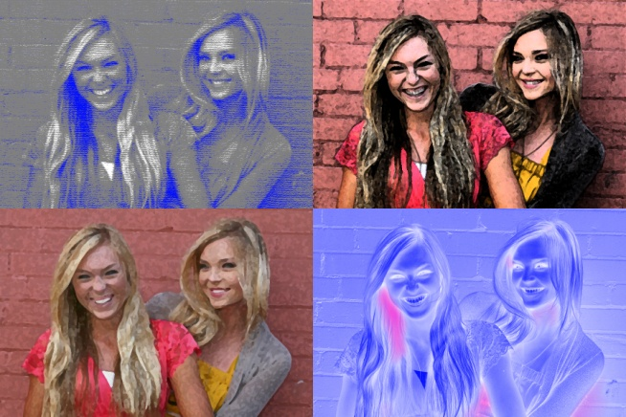
- Define the following:
  - Angel of View

  - Camera Angles

  - Exposure

